**CSCE 3612: Embedded Systems Design**

**Lab 1 – Embedded Computing**

**Due: End of recitation on July 6, 2022  
Deliverable: At least two of the three tasks below**

**1.How would you measure the execution speed of a program running on a microprocessor? You may not always have a system clock available to measure time. To experiment, write a piece of code that performs some function that takes a small but measurable amount of time, such as a matrix algebra function. Compile and load the code onto a microprocessor, and then try to observe the behavior of the code on the microprocessor’s pins.**

**2.Develop the requirements description for an interesting device. The device may be a household appliance, a computer peripheral, or whatever you wish.**

Requirement is a level in the abstraction of the embedded system design process which is used to record the detailed necessities of a customer before modeling it as a design.

* The computer peripheral taken for developing the detailed requirement is LAN switch.
* The following are the detailed requirements for the development of a LAN switch.
* The LAN switch must be designed as a solid product.
* The LAN switch must be portable, lightweight, and must possess precise functions.
* The LAN connections must be developed as a simple structure to recover from failure if occurs.
* The LAN cables must be of reliable Ethernet cables that comply with the standards laid down by the IEEE consortium.
* The LAN switch must be designed to meet the environmental standards in general.
* The LAN switch must comply with the green environment to sustain for a longer period on operation.
* Identification codes must be given for every circuits and blocks available in the design of the LAN switch.
* The LAN switch must produce higher efficiency in terms of performance.
* Proper slots for connectivity must be provided in the design of a LAN switch.
* Traffics shall be monitored and maintained throughout the LAN switch continuous operation.
* There must be a route backup in every LAN switch that is being designed in order to recover the original operations to the fullest speed.
* The system functions must be provided with auto configuration so that individual shall access the LAN switch without any third party intervention.
* The LAN switch cautions must be provided in detail at the backside of every LAN switch to avoid any voltage fluctuation issues.

**3.Write a specification for an interesting device in UML. Try to use a variety of UML sequence diagrams, including class diagrams, object diagrams, sequence diagrams, and so on.**

Specification of a device is one of the abstraction levels in the embedded system design process. Specification acts as a bridge between the customer requirements and the architects. Specification describes the behavior of the system as per the requirement of customer in detailed manner.

The unified modeling language (UML) visually represents the behavior of any systems with its role, actors, states in which the system is in, activities performed by the system, sequences between different roles, and the collaboration between the system roles.

The device taken for providing specification is the automatic teller machine (ATM) and its

applications.

The UML specification of ATM machine system has two main classes which controls all the other classes namely Bank class and ATM class.

* **Bank class** has the behavior of manages and maintains with the objects code and the address of bank branches.
* **ATM class** has the behavior of identification and transactions along with the objects location and managed.

There are four classes in the specification of ATM machine system namely Debit Card, Customer, ATM Transaction, and Account.

* **Debit Card class** has the complete control over the behavior access with the object card number and the attribute owned by.
* **Customer class** has the behavior of the own with the attributes name, address and the date of birth of the particular customer.
* **ATM Transaction class** has control on the updating behavior with the transaction id, date and the type of the transaction need to be made.
* **Account class** has control over the balance check behavior along with the attributes type of account and the owner of the account holder

There are four generalized class in the specification of the ATM machine system namely saving account, current account, with drawl transaction and transfer transaction.

* **Savings account class** can make transactions such as debit as well as credit behavior with account number as the attribute.
* **Check account class** can also make transactions such as debit as well as credit behavior with account number as the attribute.
* **Withdrawal transaction class** has complete control on the with drawl behavior with amount as the attribute.
* **Transfer transaction class** has the attributes amount and amount id which acts a the reference to the with drawl transaction from the ATM machine.

**Class diagram**

The following figure shows the class diagram of an ATM machine system.

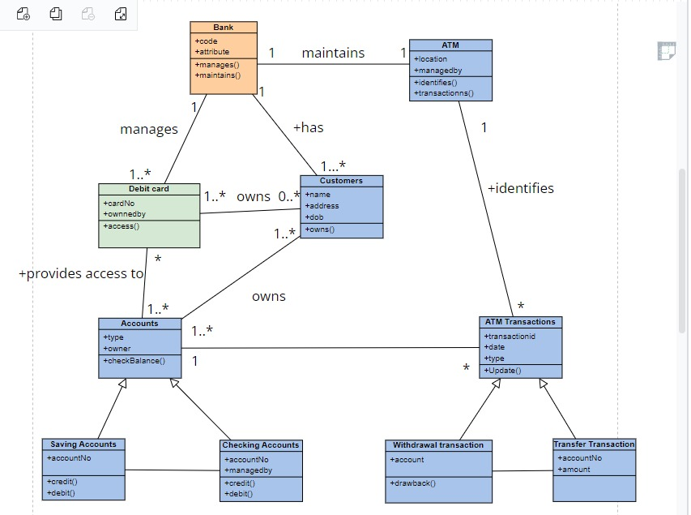

**Sequence Diagram**

The following is a sequence diagram that describes the operations of an ATM machine system in a detailed manner.

**Collaboration Diagram**

The following is the collaboration diagram of an ATM machine system.

